1. **Perform basic Image Handling and processing operations on the image• Read an image in python and Erode an Image using erode function.**

**Aim:**

The Aim of the experiment is to Read an image in python and Erode an Image using erode function.

**Code:**

import cv2

import numpy as np

path = "C:\\Users\\prith\\Documents\\CV\\cvimage.jpg"

img = cv2.imread(path)

imgGray = cv2.cvtColor(img, cv2.COLOR_BGR2GRAY)

kernel = np.ones((5, 5), np.uint8)

imgEroded = cv2.erode(imgGray, kernel, iterations=1)

cv2.imshow('Original Image', img)

cv2.imshow('Eroded Image', imgEroded)

cv2.waitKey(0)

cv2.destroyAllWindows()

**Input:**

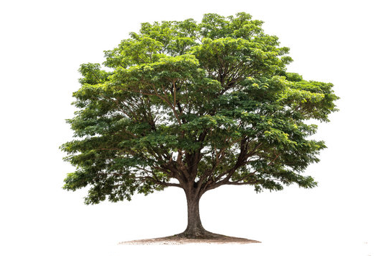

**Output:**

**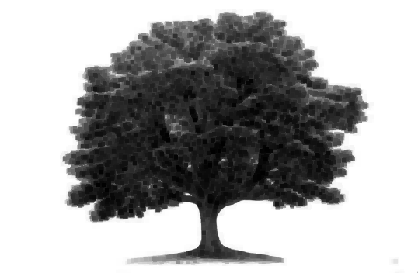  
  
Result:**

The python program to erode an image is successfully executed.